Training Instructions

CITI website: https://about.citiprogram.org/

- One the main page select: ‘Register’ if you do not already have an account.

- Type in “Illinois State University” in the ‘Select your Organization Affiliation’ box. Select the box next to ‘I AGREE to the terms of service….’ and the “I affirm” statement and then select ‘Create a CITI Program account’.
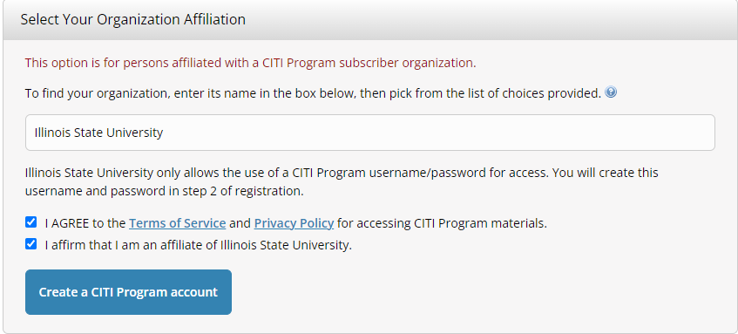

- Complete your personal information with your ISU email address. Select ‘Continue to Step 3’.
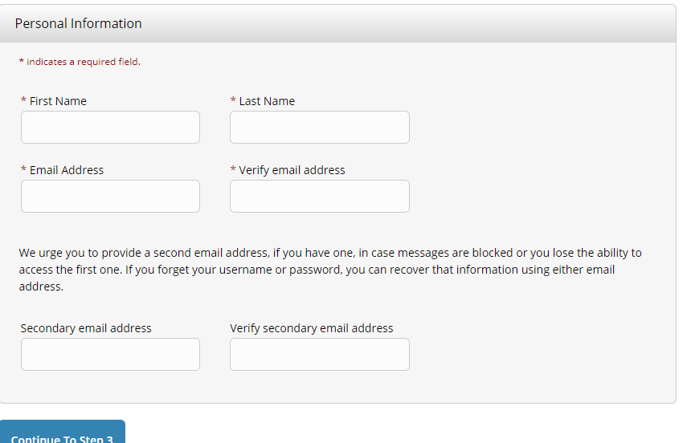
- Create a username and password. Identify a security question and then click on ‘Continue to Step 4’.
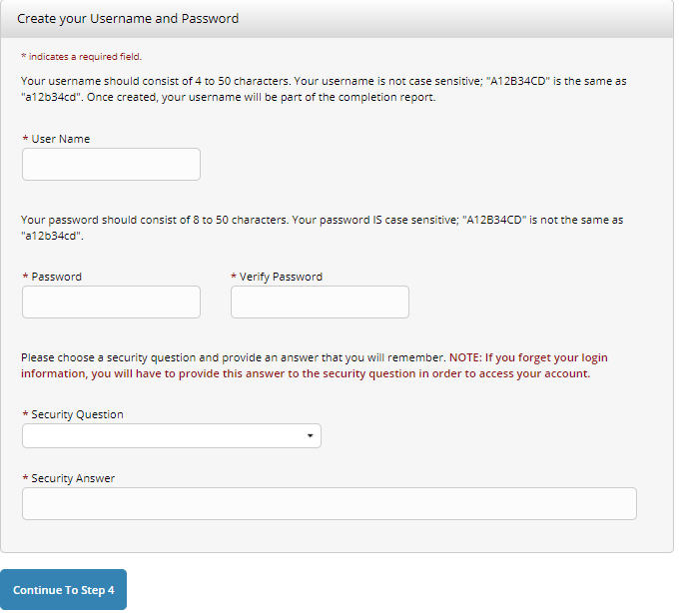

- Enter your country of residence and respond to the contact question. Select ‘Finalize Registration’.
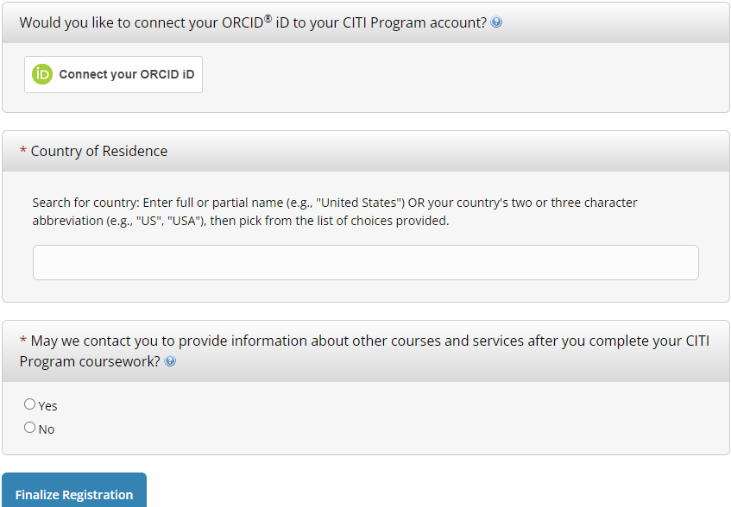

- Respond to ‘Your CE Credit Status’ question. Select ‘Submit’
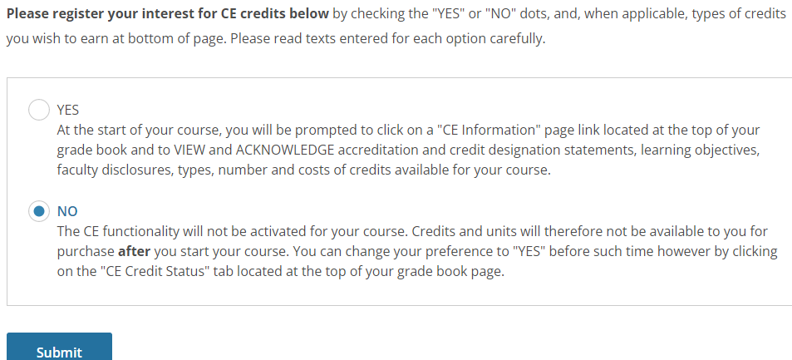
Select: ‘no’

- Enter your required profile information requested. Select “other” for the course you intend to take and then select ‘next’.

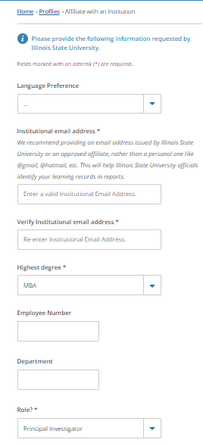

- Respond to all the questions to Select Curriculum. Questions 1-3, 5 should be marked “none of the above, I am interested in other CITI training courses’.
Question 4: select ‘CITI Export Controls’.
Questions 7-9: Select ‘no’.
Questions 6 and 10 can be left blank.
Select: ‘Submit’
- The course you select should now appear. Select ‘Start now’.

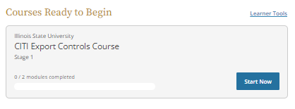

- A list of all modules for Export Control training appears. Select ‘start’ next to the module you need to complete.

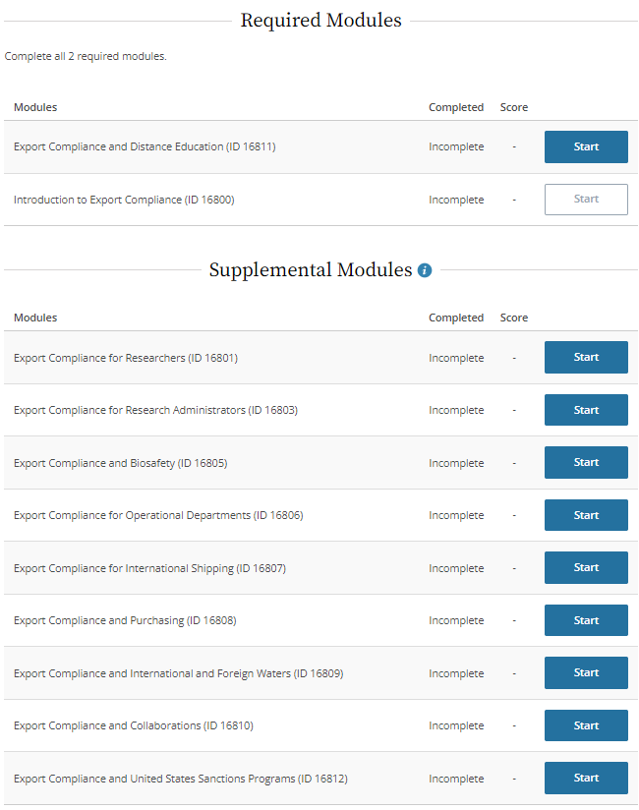
- If you have any problems with completing the modules, feel free to contact Research and Sponsored Programs at (export@ilstu.edu).

